

Лабораторная работа № 9
По дисциплине: Поддержка и тестирование программных модулей

Выполнила:
Пашина Валентина Петровна

г. Улан-Удэ
2026 г.

Листинг кода MathFunctions:

using System;

namespace LR90102
{
public static class MathFunctions
{
public static double Csc(double x)
{
double sin = Math.Sin(x);
if (Math.Abs(sin) < 1e-10)
throw new DivideByZeroException("csc: sin(x) слишком близок к 0");
return 1.0 / sin;
}
public static double Cot(double x)
{
double tan = Math.Tan(x);
if (Math.Abs(tan) < 1e-10)
throw new DivideByZeroException("cot: tan(x) слишком близок к 0");
return 1.0 / tan;
}
public static double LogA(double x, double baseVal)
{
if (x <= 0)
throw new ArgumentException("log: x должен быть > 0");
if (baseVal <= 0 || Math.Abs(baseVal - 1) < 1e-10)
throw new ArgumentException("некорректное основание логарифма");
return Math.Log(x) / Math.Log(baseVal);
}
public static double Log2(double x) => LogA(x, 2.0);
public static double Log3(double x) => LogA(x, 3.0);
public static double Log5(double x) => LogA(x, 5.0);
public static double Log10(double x) => LogA(x, 10.0);
}
}

Листинг кода TargetFunctions:
using System;

namespace LR90102
{
public static class TargetFunctions
{
public static double F1(double x)
{
double tanMinusCos = Math.Tan(x) - Math.Cos(x);
double cscMinusCos = MathFunctions.Csc(x) - Math.Cos(x);
double numerator = tanMinusCos - cscMinusCos;
double step1 = Math.Pow(numerator, 2);
double step2 = step1 / MathFunctions.Cot(x);
double step3 = Math.Pow(step2, 2);
return step3;
}
public static double F2(double x)
{
double part1 = MathFunctions.Log3(x) + MathFunctions.Log2(x);
double part2 = part1 / Math.Pow(MathFunctions.Log5(x), 3);
double part3 = part2 + MathFunctions.Log10(x);
double result = part3 + MathFunctions.Log10(x);
return result;
}
}
}

Листинг кода IntegrationTests:
using System;

namespace LR90102
{
class IntegrationTests
{
static void Main()
{
Console.WriteLine("ИНТЕГРАЦИОННОЕ ТЕСТИРОВАНИЕ\n");
Console.WriteLine("| {0,-12} | {1,-20} | {2,-20} |", "x", "F1(x) (x<=0)", "F2(x) (x>0)");
Console.WriteLine(new string('-', 60));
double[] testValuesNegative = { -2.0, -1.0, -0.5, 0.0 };
foreach (double x in testValuesNegative)
{
try
{
double result = TargetFunctions.F1(x);
Console.WriteLine("| {0,-12} | {1,-20} | {2,-20} |", x, result.ToString("E6"), "N/A");
}
catch (Exception ex)
{
Console.WriteLine("| {0,-12} | {1,-20} | {2,-20} |", x, $"Ошибка: {ex.Message}", "N/A");
}
}
double[] testValuesPositive = { 0.1, 1.0, 2.0, 10.0 };
foreach (double x in testValuesPositive)
{
try
{
double result = TargetFunctions.F2(x);
Console.WriteLine("| {0,-12} | {1,-20} | {2,-20} |", x, "N/A", result.ToString("E6"));
}
catch (Exception ex)
{
Console.WriteLine("| {0,-12} | {1,-20} | {2,-20} |", x, "N/A", $"Ошибка: {ex.Message}");
}
}
Console.WriteLine(new string('-', 60));
Console.WriteLine("\nТЕСТ СОВМЕСТИМОСТИ МОДУЛЕЙ");
double[] compatibilityTest = { -1.5, 0, 1.5, 3.0 };
foreach (double x in compatibilityTest)
{
Console.Write($"x = {x,5:F2} → ");
try
{
if (x <= 0)
Console.WriteLine($"F1 = {TargetFunctions.F1(x):E6}");
else
Console.WriteLine($"F2 = {TargetFunctions.F2(x):E6}");
}
catch (Exception ex)
{
Console.WriteLine($"Ошибка: {ex.Message}");
}
}
Console.WriteLine("\nИнтеграционное тестирование завершено.");
Console.ReadKey();
}
}
}

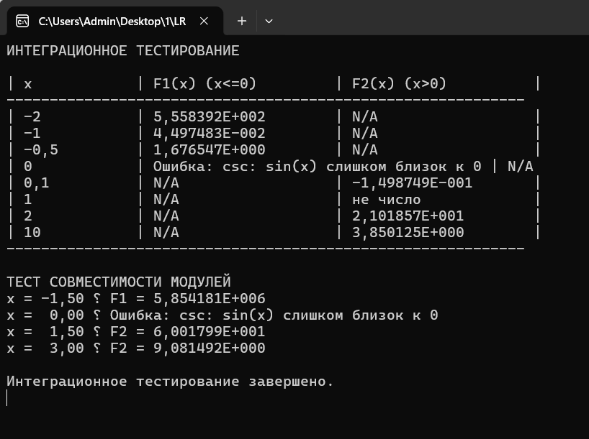
Рис. 1 «Результат»

